Chess Game Project
This project is a simple Chess Game webpage that allows users to interact with a chessboard. The page includes a navigation bar at the top, which offers links to the About section, Login page, and Sign-up page.

Key features include:
- Navbar: A clean and stylish navigation menu at the top of the page. It has links to different sections of the site, such as About, Login, and Sign-up.
- Chessboard: The main section of the page, where a 64-square chessboard will be generated dynamically. Each square can represent a chess piece in the game.
- Responsive Design: The layout is designed to be user-friendly and looks good on both desktop and mobile devices.
- Interactive Links: When users click on certain links or buttons, a message will pop up as a fun interactive feature (e.g., showing an alert when "Login" or "Sign-up" is clicked).
The project uses basic HTML, CSS, and a little JavaScript to provide the user experience.

Interactive Chess Game
This project is an interactive chess game built using HTML, CSS, and JavaScript. The main feature of the game is a dynamic chessboard where two players can play by moving chess pieces.
Key features of the project:
- Chessboard Creation:
  - The chessboard is automatically generated using JavaScript. It consists of 64 squares arranged in an 8x8 grid.
  - The squares alternate between white and black, just like a real chessboard.
- Chess Pieces:
  - The game uses Unicode characters to represent the different chess pieces (e.g., ♙ for white pawns, ♟ for black pawns, etc.).
  - Each player starts with 16 pieces placed in their initial positions on the board.
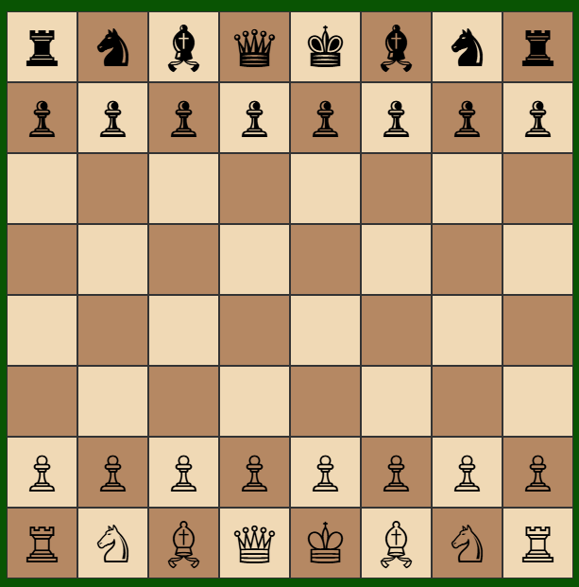

- Piece Movement:
  - Players can click on pieces and move them around the board. The game allows players to move their pieces according to the standard chess rules.
  - The game checks if the move is valid based on the piece type (e.g., pawns move differently from rooks or knights).
- Turn-based Gameplay:
  - The game alternates turns between two players. White always starts first.
  - After each move, the game switches turns automatically.
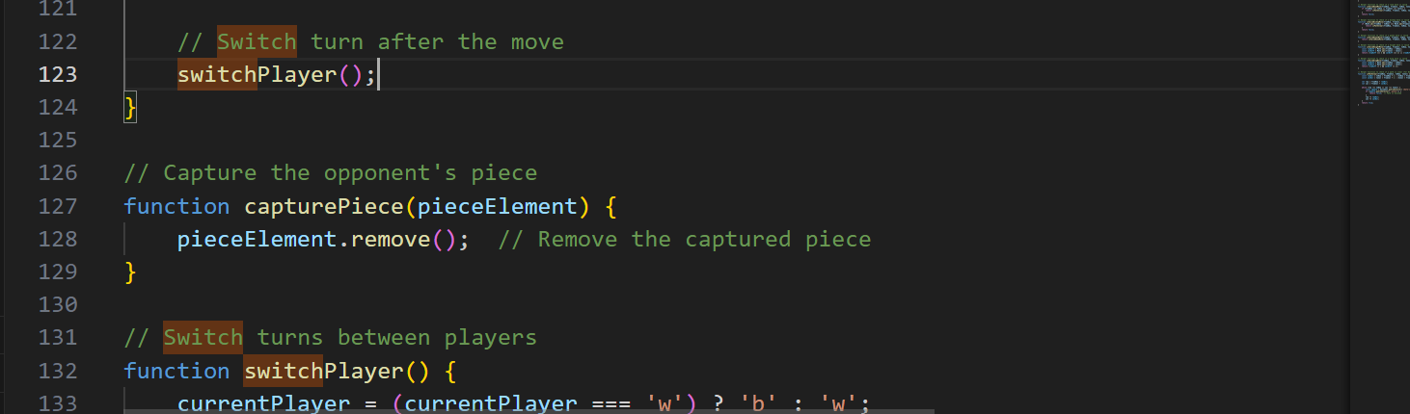
- Piece Capture:
  - If a piece moves to a square occupied by an opponent's piece, that piece is captured and removed from the board.
- Validating Moves:
  - The game includes logic to validate moves based on the type of chess piece. For example:
    - Pawns can move one or two squares forward and capture diagonally.
    - Rooks can move horizontally or vertically.
    - Knights move in an L-shape, and so on.
  - It also ensures that pieces do not move through other pieces (e.g., rooks, bishops, and queens can only move along clear paths).
- Interactive Gameplay:
  - Players can select pieces by clicking on them. If a piece is selected, it gets highlighted, and the player can move it to a valid square.
  - The game also ensures that players cannot move their pieces to squares occupied by their own pieces.

Technologies Used:
- HTML: For the structure of the game and chessboard.
- CSS: For styling the chessboard, squares, and pieces.
- JavaScript: For handling the logic of the game, piece movement, and turn-based gameplay.
This project demonstrates how JavaScript can be used to create an interactive, rule-based game, providing a fun and engaging experience for users.
